AURA: A Complete Cyber-Physical Prototype for Inventory-Aware Electronics Component Localization and Retrieval
Santosh Kumar
Department of Computer Science and Engineering
HMR Institute of Technology and Management, New Delhi, India
Academic guidance: Dr. Naveen Sharma, Professor
Supervisor: Dr. Naveen Sharma, Professor

Abstract—Electronics prototyping often slows down not at ideation but at retrieval: users may know what they want to build, yet still lose time checking whether the exact owned components exist, whether enough quantity is available, and where those parts are physically stored. This paper presents AURA, a complete cyber-physical prototype for inventory-aware electronics component localization and retrieval. The system combines an ESP32-based host device with a local display and joystick interface, low-power ATtiny404 plus nRF24L01 locator nodes, WS2812-based visual indication, and value-aware inventory records that track exact part identity, quantity, and storage address. AURA supports single-part lookup, quantity-aware stock review, addressed activation of distributed locator nodes, and multi-part retrieval workflows for accepted builds. A supporting deterministic circuit assistance layer operates on structured circuit data and local rules so that build suggestions remain auditable and tied to owned stock rather than unconstrained chat output. In the present prototype, physical retrieval remains the primary system function and software assistance remains subordinate to the hardware-centered workflow. The result is a practical electronics assistance system that reduces part-search friction while preserving an inspectable boundary between inventory, circuit reasoning, and real-world retrieval actions.
Index Terms—cyber-physical systems, electronics inventory, component localization, distributed locator nodes, inventory-aware retrieval, electronics prototyping

I. INTRODUCTION
Electronics prototyping frequently slows down at the point where digital intent meets physical storage. A user may know the circuit they want to assemble, yet still spend disproportionate time determining whether the exact resistor value, transistor variant, sensor module, or timer IC is actually owned, whether enough quantity is available, and where those parts are physically located. This gap between planning and retrieval is rarely treated as a single systems problem.
Most existing tools address only fragments of this workflow. Circuit design environments typically assume parts are available. Inventory tools may record stock but usually do not guide physical retrieval. AI-based circuit suggestion tools may produce plausible designs, but they often ignore exact owned values, quantity constraints, and the real-world step of locating the required components in storage.
AURA addresses this gap through a complete cyber-physical prototype that couples an inventory-aware host device with distributed locator nodes and a structured assistance layer. The prototype is designed so that physical retrieval remains the primary function, while software support improves feasibility checking, guidance, and circuit-oriented assistance without replacing the hardware-centered workflow.
A. Practical Problem Scope
The practical difficulty is not merely recognizing a component family. Build feasibility depends on exact values, exact package or module variants, sufficient quantity, and known physical storage addresses. A user who owns resistors in general but not the required 220-ohm or 1-kilo-ohm value still cannot complete a build. Likewise, a user who owns the required value but cannot locate it inside drawers, bins, or racks still experiences the same assembly bottleneck.
AURA treats this as one linked workflow: exact-part identification, inventory fit, storage lookup, and physical highlighting. This distinguishes the system from software-only design tools and from inventory tools that stop at record keeping.
B. Contributions
The main contribution of AURA is not a simulator or editor alone, but a complete prototype that closes the gap between knowing what to build and physically retrieving the exact owned components required to build it. The specific contributions of this work are: 1) a host-and-node cyber-physical prototype for addressed component localization; 2) an inventory model that distinguishes exact values, quantities, and physical storage addresses; 3) a retrieval workflow that links part lookup, stock review, and physical highlighting; and 4) a deterministic assistance boundary that keeps software support inspectable and subordinate to the hardware workflow.
II. COMPLETE PROTOTYPE ARCHITECTURE
AURA is organized as a complete prototype spanning four tightly linked layers: a host device and control layer, a distributed locator node layer, an inventory and storage address layer, and a support software layer. The ordering is deliberate. The host, node network, and inventory records form the primary system. Richer software surfaces and deterministic circuit assistance exist to strengthen this physical workflow rather than redefine the product as a software workspace.
A. Host Device and Control Layer
The host prototype is built around an ESP32-class controller with a compact local display, joystick-driven navigation, and radio-side authority for locator-node communication. The host acts as the control plane for local part lookup, stock review, node addressing, and locate activation. Its role is intentionally practical: it must remain usable without requiring a phone during normal operation, especially during physical retrieval tasks near storage locations.
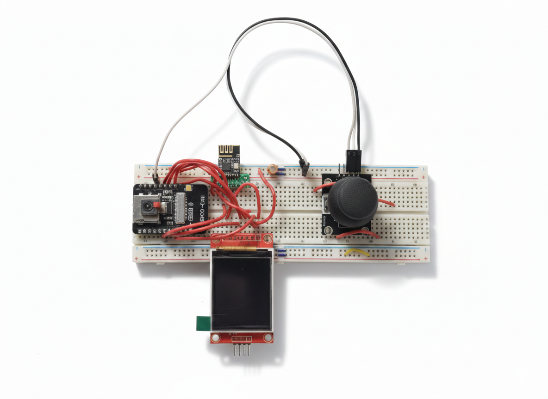
Fig. 1. AURA host prototype used for local part lookup, stock review, and locate activation.
B. Distributed Locator Node Layer
The node layer uses compact low-power controllers based on the ATtiny404 and nRF24L01, coupled to WS2812 visual indication and optionally extensible to audible cues. A node can represent one dense storage strip, one drawer row, or a larger addressed physical zone, depending on storage density. The host communicates with nodes through addressed commands, allowing exact storage positions to be highlighted instead of forcing the user to manually search an entire room or rack.
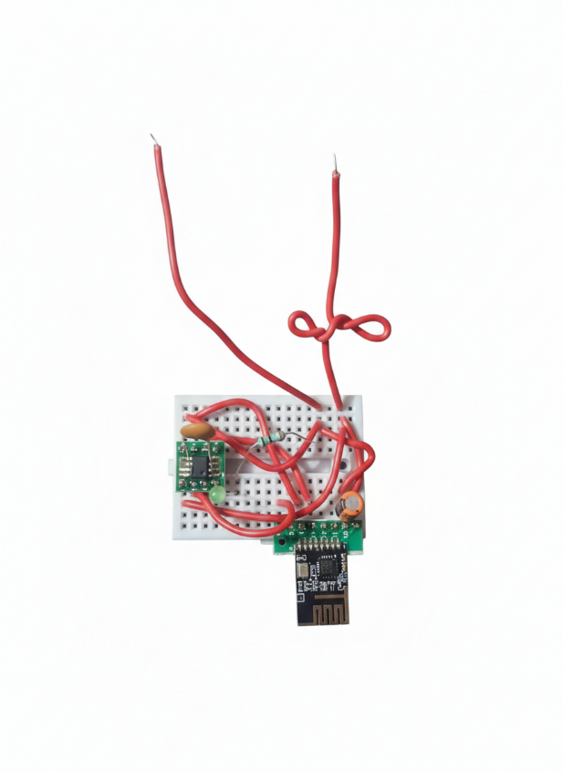
Fig. 2. Prototype locator node used for addressed physical highlighting in the AURA retrieval workflow.
C. Inventory and Storage Address Layer
Inventory records in AURA are value-aware and location-aware. Each record is intended to capture component family, exact value or variant, quantity, and storage address, with room for future notes, media, and project linkage. This layer is what allows the host to answer practical questions such as whether a specific component is owned, whether enough quantity exists for a build, and where those items are physically stored.
D. Support Software and Deterministic Assistance
A supporting phone or workspace surface may provide richer search, bulk inventory input, notes, and deterministic circuit assistance. However, that support layer is not the system identity. In AURA, software assistance exists to connect build intent to owned inventory and physical retrieval, not to replace the hardware-centered prototype with a purely virtual design environment.
III. END-TO-END OPERATIONAL WORKFLOW
AURA is best understood as an operational loop rather than a static inventory database or design workspace. The user begins with an exact part need or a build intent. The system then checks owned stock, resolves relevant storage addresses, and triggers addressed locator outputs so the user can retrieve the required components with reduced search time and uncertainty.
A. Exact-Part Lookup and Stock Review
The first stage is exact-part lookup. The user may search by name, value, or known build requirement. AURA then resolves whether the exact owned part exists, how much quantity is available, and whether the part is stored in one or multiple physical locations. This is the critical transition from abstract component thinking to actionable inventory awareness.
B. Physical Highlighting and Retrieval
Once a part or accepted parts list is confirmed, the host issues addressed radio commands to the relevant nodes. The corresponding indicator outputs then highlight the physical storage positions linked to those parts. This closes the loop that is usually absent from inventory software: the system does not stop at telling the user that a part exists; it guides the user toward the real storage location.
C. Smartphone Support Without Smartphone Dependence
A smartphone can serve as a valuable accessory surface for tasks that are cumbersome on a small embedded display, including bulk library input, richer naming, project-linked inventory preparation, and more comfortable browsing. However, the host remains the primary retrieval surface. Normal locate and stock operations must still function directly on the host so that AURA behaves as a real physical product rather than a phone app with attached hardware.
D. Deterministic Circuit Assistance as a Secondary Layer
AURA also includes a structured assistance layer for circuit-oriented work. This layer operates on canonical circuit data and local rules so that design suggestions remain auditable and tied to owned stock. The key boundary is that this assistance does not redefine AURA as merely a circuit editor. Instead, it acts as a support mechanism that helps translate build intent into inventory-aware, physically retrievable part sets.
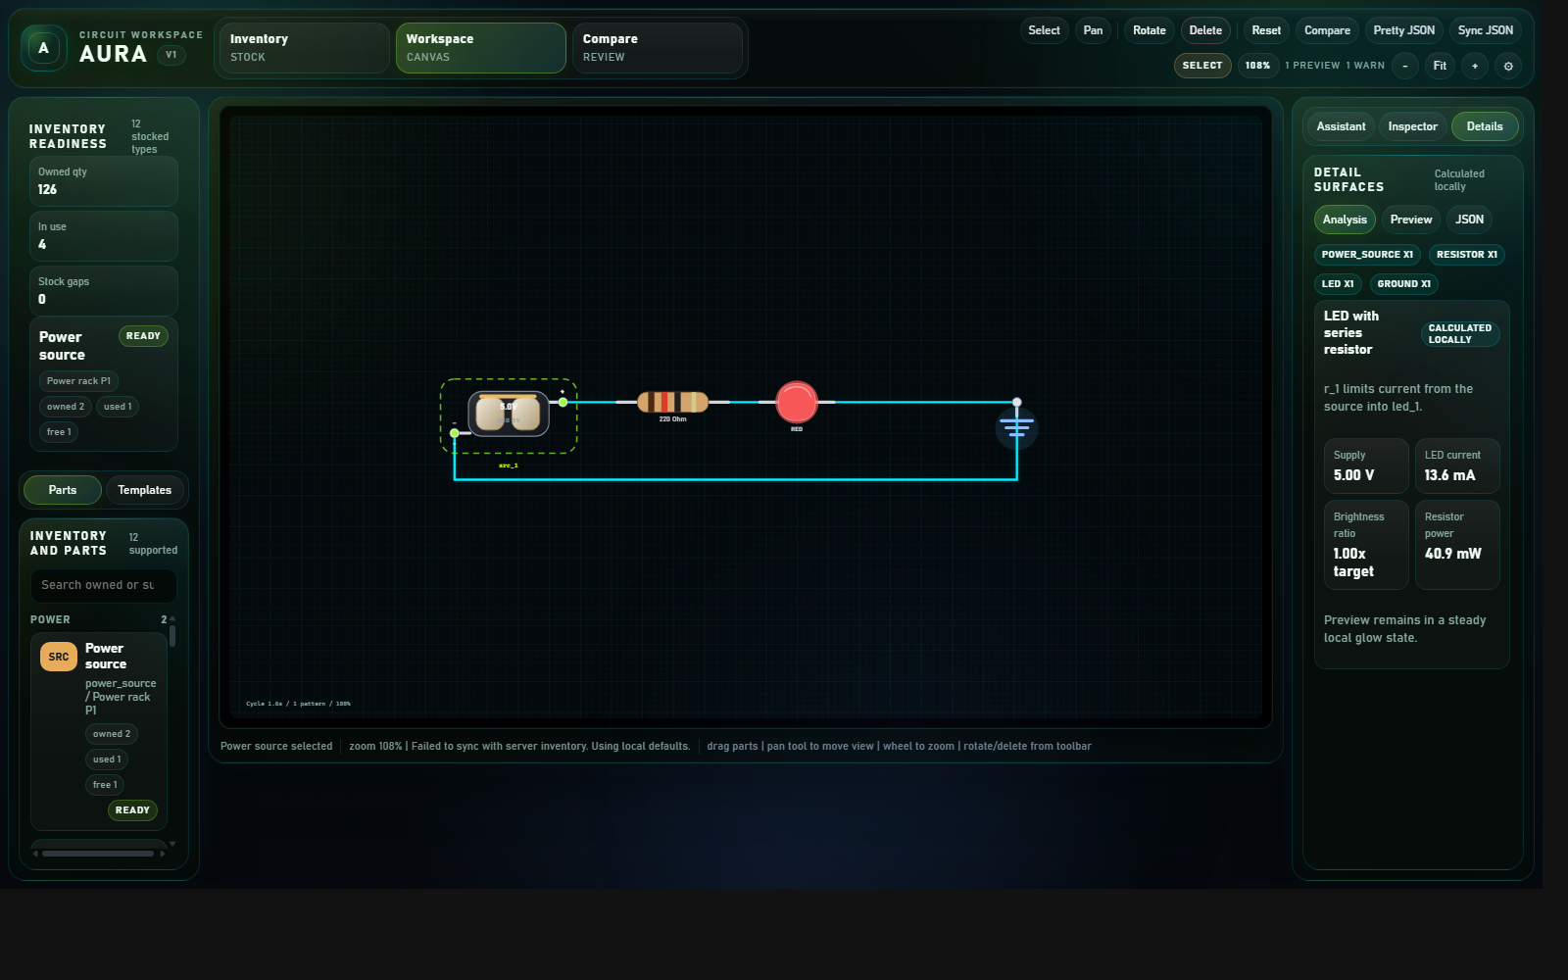
Fig. 3. Optional support workspace used for structured inventory review and deterministic circuit assistance.
IV. CURRENT PROTOTYPE REALIZATION AND VALIDATION
The presented system is a complete prototype intended to demonstrate the integrated host, node, inventory, and retrieval workflow in operational form rather than as an isolated concept or software mockup. In its current realization, AURA already supports end-to-end prototype operation across part lookup, stock awareness, node-addressed physical localization, and hardware-guided retrieval.
A. Implemented Prototype Modes
The integrated prototype currently supports single-part lookup, local stock review, addressed node activation for locate actions, and component retrieval guidance through physically mapped indicator outputs. The prototype direction also supports project-linked retrieval concepts in which multiple required components can be highlighted together after an accepted parts list or build plan is identified.
B. Representative Validation Scenarios
Prototype validation is best expressed through operational scenarios. In single-part retrieval, the host resolves an exact owned component, reviews quantity and location, and activates the mapped node output for physical highlighting. In node validation, the host tests whole-node and single-output activation so storage mappings can be verified during installation. In inventory-aware build preparation, the system filters candidate parts through known owned stock before enabling locate actions. These scenarios demonstrate that the prototype is not a disconnected set of subsystems, but an integrated retrieval pipeline.
C. Benefits of the Prototype Form
For students and beginners, AURA reduces the friction of drawer-by-drawer search and improves the transition from learning to assembly. For hobbyists and makers, it makes it easier to reason from owned stock instead of idealized parts lists. For small shared labs or project rooms, it offers a practical route to better storage discipline and faster retrieval without depending on enterprise-scale inventory systems.
V. DISCUSSION
AURA should not be evaluated as a claim of universal circuit correctness or full simulator coverage. Its value lies in treating exact-part inventory, physical storage, and component retrieval as first-class concerns within electronics assistance. The system becomes most useful when digital recommendation remains connected to real owned parts and when physical retrieval becomes a designed outcome rather than an afterthought.
This framing is important because it preserves a clear trust boundary. The host-and-node retrieval system can be directly observed in physical space. Inventory records can be inspected and corrected. Deterministic assistance can be bounded by structured data. As a result, AURA can grow in software capability without losing the hardware-centered logic that makes the prototype intelligible and trustworthy.
VI. CONCLUSION
AURA demonstrates that electronics assistance should not end at digital recommendation. By treating exact-part inventory, physical storage, and component retrieval as first-class system concerns, the prototype closes a practical gap between planning a build and physically assembling it. The resulting system is a complete cyber-physical prototype in which the host, distributed locator nodes, inventory records, and support software operate as one integrated workflow.
Future work will expand storage coverage, refine the embedded hardware, strengthen validation with broader deployment scenarios, and extend smartphone-supported input and deterministic assistance while preserving the hardware-first identity of the system. The core result remains stable: AURA turns exact-part availability and physical retrieval into explicit, inspectable system functions rather than leaving them outside the scope of electronics design support.
REFERENCES
[1] Espressif Systems, "ESP32 Technical Reference Manual," 2023.
[2] Microchip Technology Inc., "tinyAVR 0-series Family Data Sheet," 2024.
[3] Nordic Semiconductor, "nRF24L01+ Single Chip 2.4 GHz Transceiver Product Specification," 2019.
[4] Worldsemi, "WS2812B Intelligent Control LED Integrated Light Source Data Sheet," 2020.
[5] Bluetooth SIG, "Bluetooth Core Specification," Version 5.x.
[6] Arduino, "SPI Communication," Arduino Documentation.
[7] SQLite, "SQLite Documentation," Documentation.
[8] P. Horowitz and W. Hill, The Art of Electronics, 3rd ed. Cambridge, U.K.: Cambridge Univ. Press, 2015.
[9] IETF, "JavaScript Object Notation (JSON) Patch," RFC 6902, 2013.

